Kevin Nunez 00323217 Fall2026 Awk Lab Adrianna Holden Gouveia
09/24/2026
Important Information about the lab: When you are doing this assignment is important to download the AwkLab file correctly in your virtual machine and remember the name for the code.
1. Print all the First Names.
The command is awk '{print$1}' AwkLab
To print first names, we need to know how our file looks.
The Name is the first field. The Phone Number is the second field. And the remaining 3 fields are contributions that are made by each person.
That means $1 equals first names, and that is also the first field.

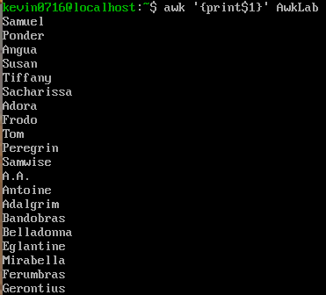

2. Print phone numbers for Tom and Frodo after their names
The command is awk -F: '/^Tom|Frodo/{print $1” “ $2}' AwkLab
We use -F parameter to declare a space. In this example we use the colon as field space. Same concept as the previous code that we did in the last one. We are printing the second field $2 and the $1 that means neames, and the $2 is the phone numbers are located there. The only difference is that we need to write the person’s name’/ Tom|Frodo/’ enclosed in backslash to search for their numbers.

3. Print Peregrin’s full name and phone number area code only.
The command is awk '/^Peregrin/{print $1" "$2 }' AwkLab
$1 means the first field like the past codes. $2 is the second field what it is numbers. The incorporation of the quotations “ “ is to separate them so they don’t stick together. It adds space between those two columns. So, the outcome between $1 and $2 comes separately.
4. Print all phone numbers (full number) in the 123-area code along with the names
The command is awk -F: '/(123)/ {print $1” “ $2}' Awklab
We use -F parameter to declare a space with a colon. We enclose the (123) between parentheses because we are looking for that specific combination to work with. Then we print the $1 and $2 because that is the field where the numbers are located. In summary, we are telling awk to grab the code area (123) and print the rest of the field that is $2 in this case and $1 is the names.
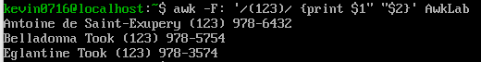

5. Print all Last names beginning with either a T or D (careful of middle names!)
The command is awk -F"[ :]" '$3~/^(T|D)/{print $3}' AwkLab
We use -F to create a space or colon. Printed the $3 because it is now limited by the space, so this means is going to print the second match allowing us to print the last names with T or D.
^: Indicates the beginning of the line
~ : Means match after this line
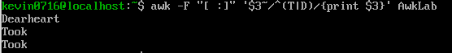’
6. Print all first names containing four or less characters.
The command is awk '4 >= length($1) {print$1}' AwkLab
Here we want to know what we need and what we are looking for. We are going to start this problem to make the range of the search with 4 >= length ($1). This expression means look for the first four or less characters in the first field that the first names are located or $1. Later, for first names we use {print$1} to print the field where the first names are located and going to be searched, and after that printed.
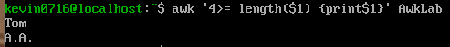
7. Print the first names and area codes of all those in the 916 area code.
The command is awk '/(916)/{print $1}' AwkLab
We specify the code by enclosing it between parenthesis (916). Then print the first field $1. So, then this will print the first names of the ones containing the area code 916.
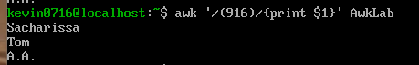

8. Print Sacharissa’s campaign contributions following her name. Each value should be printed with a leading dollar sign; e.g., $250 $100 $175.
The command is awk -F: '/Sacharissa/{print "$"$3,"$"$4,"$"$5}' AwkLab
We are going to use awk with the -F parameter to declare a separator, space or colon. In this example we use the colons as the field separator, now we start by searching the name Sacharissa, after that we want awk to print dollars sign for each field. To add them we write a dollar sign “$“. If we do not add the field separator expression, it just going to only print a dollar sign for only one field. So, we need to use it as this /{print “$” $3, “$”$4, “$”$5’}. This expression means, to print a string $ for all these fields.

9. Print last names followed by a comma and the phone number. Be careful of the last name’s format.
The command is awk -F: 'match($0,/\w+:/){print substr($0,RSTART,RLENGTH-1),$2}' AwkLab
Explanation: We need awk with -F to create a separator, space or colon, with awk matches the entire line to get the last name of the person, and now \w to identify any character as part of the last name.
Substr : can be used to select a subtract from the input.
RSTART: This stores the starting location of the search string/pattern.
RLENGTH: This stores the length of the search string/pattern.

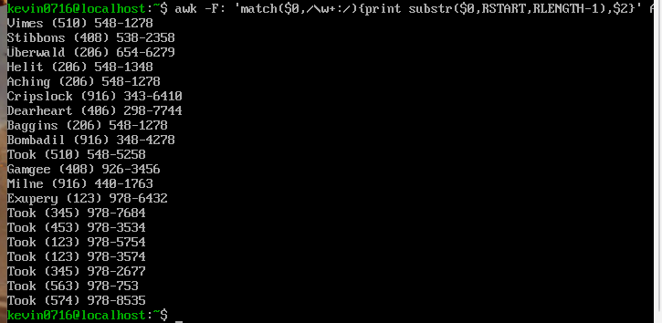

10. Print the first and last names of those who contributed more than $110 in the last month. Make sure to include their last month contribution amount after the name
The command is awk '$4>110 {print$1}' FS=':' AwkLab
$4 represents the field 4 or the second month. If there is a number “>” greater than 110 in the field 4, print field $1 which correspond to the person full names.
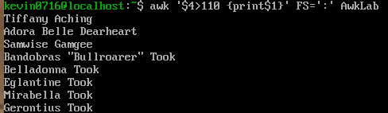
11. Print the last names, phone numbers, and first month contribution of those who contributed less than $150 in the first month.
- The command is awk -F':' '{if ($3 < 150) print $1 " " $2}' AwkLab | awk '{for (i=2; i<=NF;i++) printf $i " " ;print " "}'
For the first part I needed -F to separate, space or colon. The next part is printing the contributions of the first month of the people that contributed less than 150, and we use {if ($3 < 150) to print the first month and the contribution less than $150.
After we use print $1 " " $2 as a sequence of printing the first and second field were the name, and the number are located. awk '{for (i=2; i<=NF;i++) printf $i " “; print " "}'. This command is used to eliminate the first name and allows you to print the last name with the phone number in this case.

12. Print the first names and contribution of those who contributed between $10 and $200 in the first month.
The command is awk '$3>10 && $3<200 {print$1}' FS=':' Awklab
Here a get some records because is normal people donate at least 10 dollars, and like the last code we can print an exact record, and in this option, we add the “&”, for put the two statements together.
FS : Field Separator . Same as -F to separate as either a space or colon.
&& = and
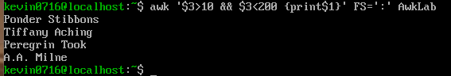
13. Print the first name, last names and total contributions of those who contributed less than $700 over the three-month period.
The command is awk '{x=$3+$4+$5}x<700 {print $1}' FS=':' AwkLab
For this we need to add all the months, but first, we must create a variable, so let’s use as a variable “x”, within the variable, we added field $3, $4, $5 to identify it as the 3 months, then in the expression, we said if x is less than < 700, print field $1 which correspond to the person names.

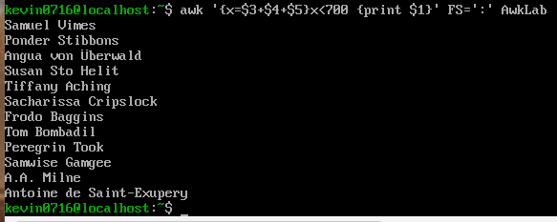

14. Print the first names and first letter of the last name, and average contribution of those who had an average contribution of more then $300
The command is awk -F: 'match($0,/\w+:/){avg=($3+$4+$5)/3;if(avg>300){print substr($0,0,RSTART)}}' AwkLab
We use -F to separate, space or colon, now we need to match the first letter of their last name, and for the average variable will be used to combine the contribution and divide it by the amount of contribution, with this if someone have an average larger than a 300, the name will be printed with the first letter of their last name.
Substr: can be used to select a substring from the input.
RSTART: This stores the starting location of the search string/pattern.

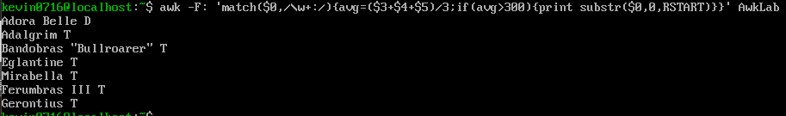

15. Print the last name and area code of those not in the 916 area code.
The command is awk -F: '!/(916)/{match($0, /\w+:/);print substr ($0,RSTART,RLENGTH-1)}' AwkLab
We need to use -F to separate, space or colon, and the “!” will be used to don’t allow the (916) shows in the expressions of the code, and for the match to get the last name index and printed it using substring 916 was not their area code.
Substr: can be used to select a substring from the input.
RSTART: This stores the starting location of the search string/pattern.
RLENGTH: This stores the length of the search string/pattern.
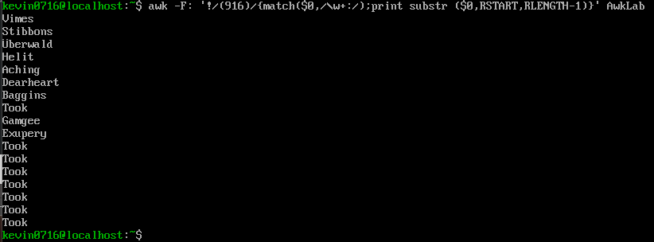

16. Print each record preceded by the number of the record.
The command is awk '{print NR,$0}' AwkLab
I found an expression to solve this on another page. So, this will display the number of the records in a file.
NR: The number of records.
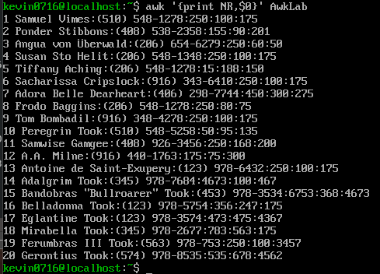

17. Print the name and total contribution of each person.
The command is awk '{x=$3+$4+$5}{print $1, x}' FS=':' AwkLab
We need a variable and then add all the contributions fields to find the total.
FS: Field Separator. Same as -F to separate, space or colon.
We create a variable call its “x” , now we add the fields that contain the contributions that are $3, $4, and $5, and after it adds together at the end.
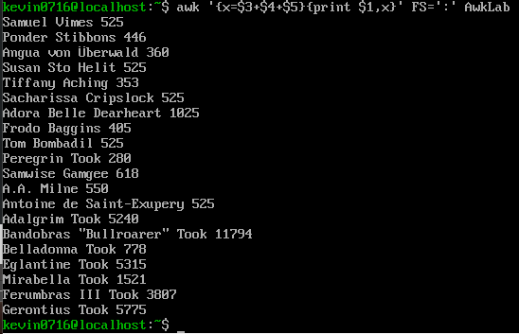
18. Add $10 to Tiffany Aching’s first contribution and print her full name and first contribution.
The command is awk -F: '/Tiffany Aching/{print"$" $3+10}' AwkLab
Here we start with awk -F to separate, space or colon. $3 represents the first contribution field, and now we print the first contribution field which is $3 plus 10

19. Change Samwise Gamgee’s name to Sean Astin
The command is awk '{gsub(/Samwise Gamgee/,"Sean Astin");print $0}' AwkLab
Replace the old name (Samwise Gamgee) with the new name (Sean Astin)
gsub: Global substitution. This one is the function that let us make these changes from a previous name to new one.

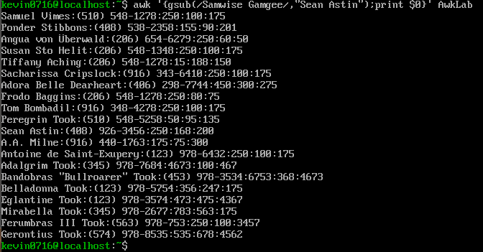

20. Write an awk script to do the following (MUST be an awk script not just a bash script or commands on the command line)
(a) Prints first name of the all the Tooks followed by their total campaign contributions.
We have almost the same problem in question 8, I just need to change names, and I get the first code for the first problem on the script.
(b) Print the full names and contributions of anyone who contributed between $10 and $200 in the last contribution
In question number 12 we have the same process too, but I changed for just analyzed the last contribution and in this case is $5, and we have the second part of the script.
(c) Prints the full names and average contribution of those who contributed less than $300 on average
The question number 14 is equal, but we need to change the > 300, is < 300 and we have the names of those that applied this condition.
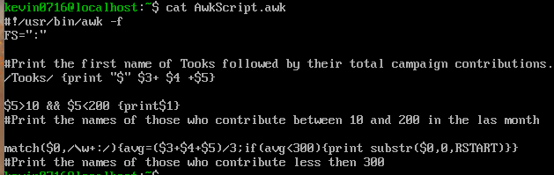
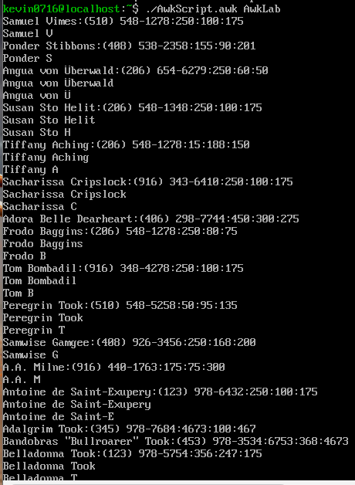
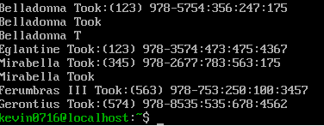

References:
https://docstore.mik.ua/orelly/unix3/sedawk/ch09_02.htm
https://translate.google.com/translate?u=https://www.digitalocean.com/community/tutorials/awk-command-linux-unix&hl=es&sl=en&tl=es&client=sge
https://www.youtube.com/watch?v=4HpWO_RAMq4&ab_channel=AdriannaHolden-Gouveia
https://flylib.com/books/en/4.356.1.53/1/

https://www.geeksforgeeks.org/linux-unix/awk-command-unixlinux-examples/

